Product & User Funnel Analytics — Business Report
1. Executive Summary
The analysis evaluated the complete e-commerce user journey from Website Visit → Product View → Add to Cart → Checkout → Purchase across 120,000 sessions.
The overall purchase conversion rate is 6.82%, with 8,181 completed purchases. The analysis identifies two major areas of funnel leakage:
- Product → Cart: 65.13% drop-off — the largest bottleneck.
- Checkout → Purchase: 49.61% abandonment — the second-largest bottleneck.
Segment analysis shows that device, acquisition channel, and campaign type have relatively small differences in conversion performance. This suggests that the primary opportunity is not to fix one particular traffic source or device, but to improve the overall product and checkout experience.

2. Business Problem
The company generates substantial website traffic but converts only a small proportion of sessions into completed purchases.
The business needs to understand:
- Where users are dropping out of the funnel.
- Whether certain devices perform significantly worse.
- Which acquisition channels generate high-quality traffic.
- Which campaign types perform best.
- How significant cart and checkout abandonment are.
- Where optimization efforts are likely to generate the greatest business impact.

3. Analysis Scope
The analysis covered seven key areas:
- Overall Funnel Performance
- Funnel Drop-off Analysis
- Funnel Analysis by Device
- Funnel Analysis by Acquisition Channel
- Campaign Performance Analysis
- Cart Abandonment Analysis
- Checkout Abandonment Analysis

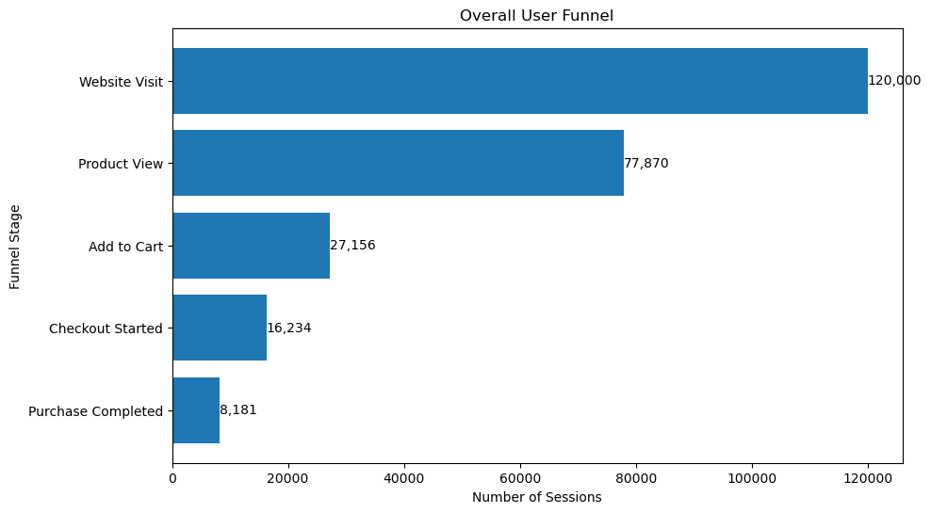
4. Overall Funnel Performance:
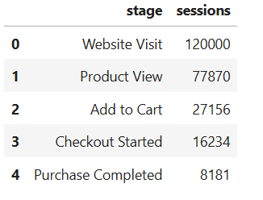
Key Findings:
- 120,000 sessions entered the funnel.
- 77,870 sessions reached a product page.
- 27,156 sessions added products to their cart.
- 16,234 sessions started checkout.
- Only 8,181 sessions completed a purchase.
- Overall conversion from website visit to purchase is 6.82%.

5. Funnel Drop-off Analysis:
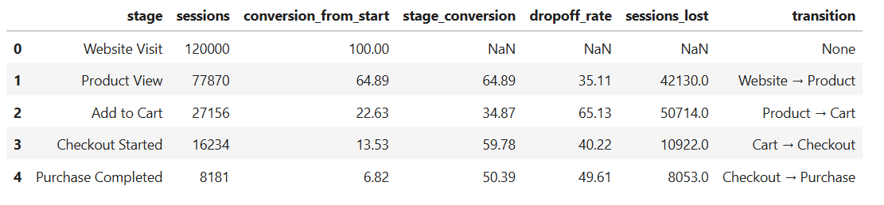

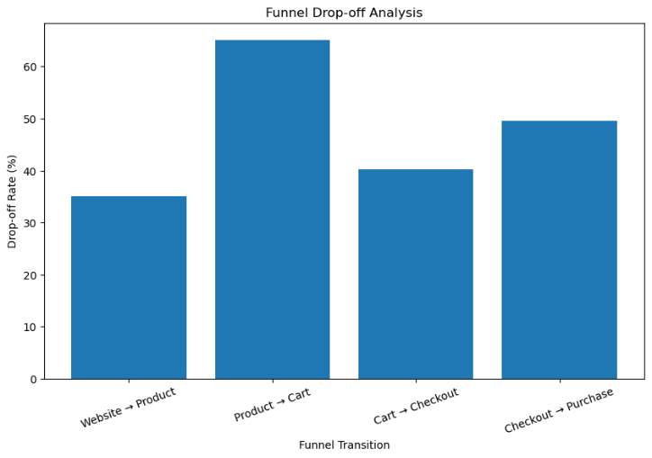
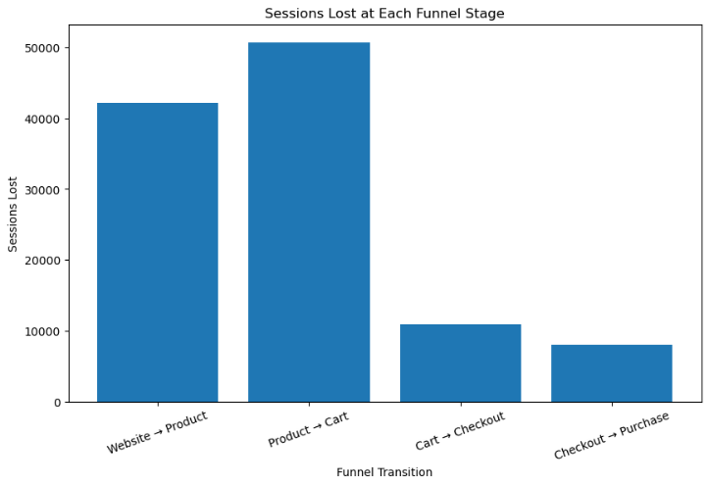

Business Insights:
- The overall funnel generated 120,000 website-visit sessions, but only 8,181 sessions resulted in a purchase, giving an overall conversion rate of 6.82%.
- The first significant drop-off occurs between Website Visit → Product View, where 35.11% of sessions are lost. This indicates that a considerable number of visitors do not progress to product evaluation.
- The largest bottleneck is Product View → Add to Cart, with a 65.13% drop-off. This results in 50,714 lost sessions, making it the most important stage to investigate and optimize.
- Cart → Checkout performs relatively better, with a 59.78% conversion rate. However, 40.22% of cart sessions still drop off, representing another opportunity to improve the purchase journey.
- The Checkout → Purchase stage has a 49.61% drop-off, meaning almost half of users who start checkout don't complete their purchase. This is the second major funnel problem and could have a direct impact on revenue.

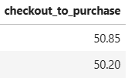
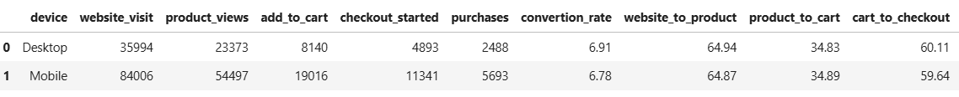
6. Funnel Analysis by Device:
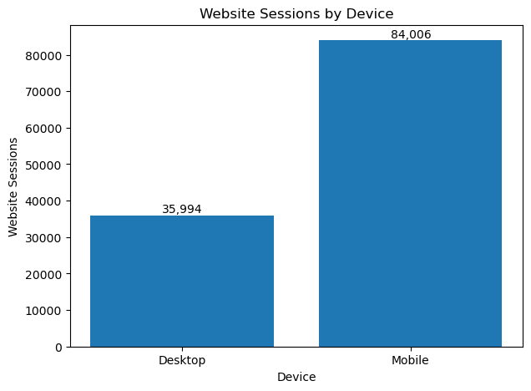

Business Insights:
- Overall conversion is almost identical across devices: Desktop converts at 6.91%, while Mobile converts at 6.78%. The difference is only 0.13 percentage points, so there is no major device-level conversion gap.
- Mobile drives the majority of traffic: Mobile accounts for 84,006 sessions (70%), compared with 35,994 desktop sessions (30%). Therefore, even small improvements in mobile conversion could have a meaningful business impact.
- Website → Product performance is nearly identical: Desktop converts at 64.94% and Mobile at 64.87%. This suggests that mobile users are reaching product pages at almost the same rate as desktop users.
- Product → Cart is also almost identical: Desktop conversion is 34.83%, compared with 34.89% on Mobile. This is particularly important because your overall analysis identified Product → Cart as the biggest funnel bottleneck, but the problem is not specific to one device.
- Cart → Checkout is slightly better on Desktop: Desktop converts at 60.11%, compared with 59.64% on Mobile. The difference is small (0.47 percentage points).
- Checkout → Purchase: Desktop converts at 50.85%, while Mobile converts at 50.20%. However, the difference is still only 0.65 percentage points, so it is not large enough to indicate a major device-specific problem.

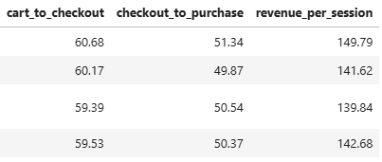
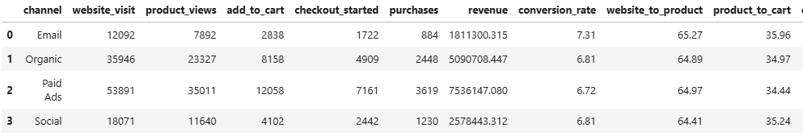
7. Funnel Analysis by Acquisition Channel

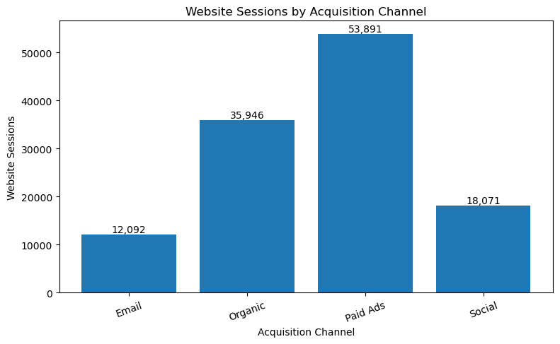

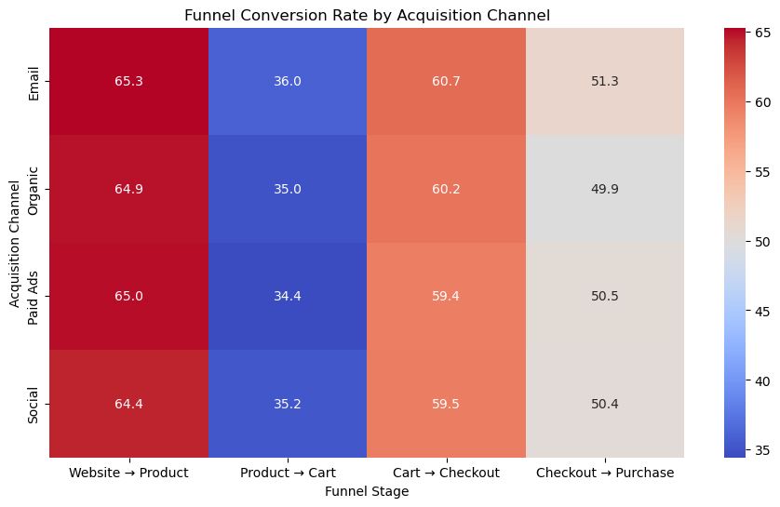
Business Insights:
- Paid Ads is the largest acquisition channel, generating 53,891 sessions, 3,619 purchases, and ₹7.54M revenue.
- Email has the highest conversion rate at 7.31% and the highest revenue per session at approximately ₹149.79.
- Organic is a strong balanced channel, generating 35,946 sessions, 6.81% conversion, and ₹5.09M revenue.
- Social has 18,071 sessions and 6.81% conversion, performing similarly to Organic.
- Product → Cart is the biggest funnel bottleneck across every channel, with conversion ranging from 34.44% to 35.96%.
- The small variation in Product → Cart conversion suggests the bottleneck is not strongly channel specific.
- Checkout → Purchase performance is also consistent across channels, ranging from 49.87% to 51.34%.
- Overall conversion varies only from 6.72% to 7.31%, indicating that acquisition channel is not a major driver of overall conversion differences.

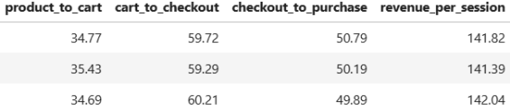
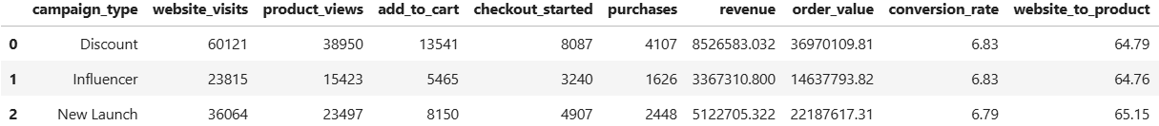
8. Campaign Performance Analysis

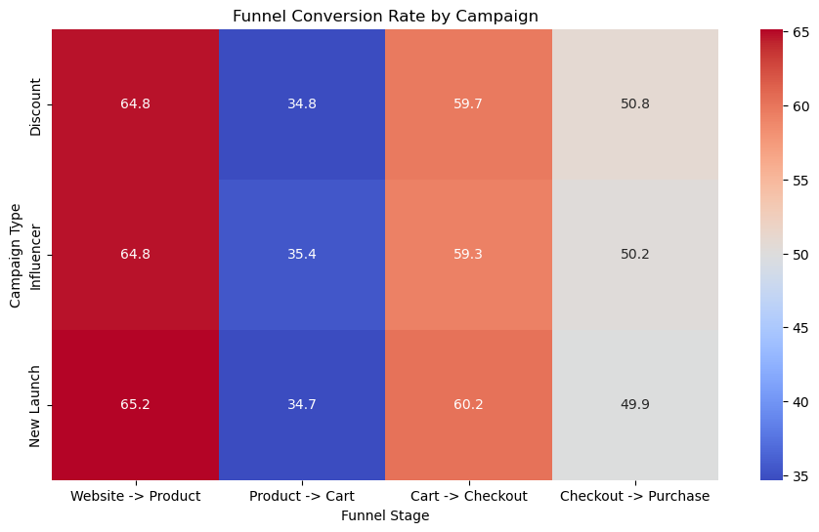
Insights:
- Discount campaigns generate the highest scale, with 60,121 sessions, 4,107 purchases, and ₹8.53M revenue.
- New Launch campaigns have the highest revenue per session at ₹142.04, slightly ahead of Discount (₹141.82) and Influencer (₹141.39).
- Conversion rates are almost identical across all campaign types:
  - Discount: 6.83%
  - Influencer: 6.83%
  - New Launch: 6.79%
- Website → Product conversion is also very consistent, ranging from 64.76% to 65.15%, indicating that campaign type has little impact on initial product discovery.
- Product → Cart remains a major bottleneck across all campaigns, with conversion ranging from 34.69% to 35.43%.
- Influencer campaigns have the highest Product → Cart conversion at 35.43%, but the difference from New Launch (34.69%) is relatively small.
- Cart → Checkout conversion is strongest for New Launch campaigns at 60.21%, while Influencer campaigns are lowest at 59.29%.
- Checkout → Purchase conversion is relatively consistent, ranging from 49.89% to 50.79%.
- The overall similarity in conversion rates suggests that campaign type is not a major driver of funnel conversion in this dataset. Discount campaigns are the strongest channel by overall business scale, while New Launch campaigns are slightly more efficient in terms of revenue per session.

9. Cart Abandonment Analysis
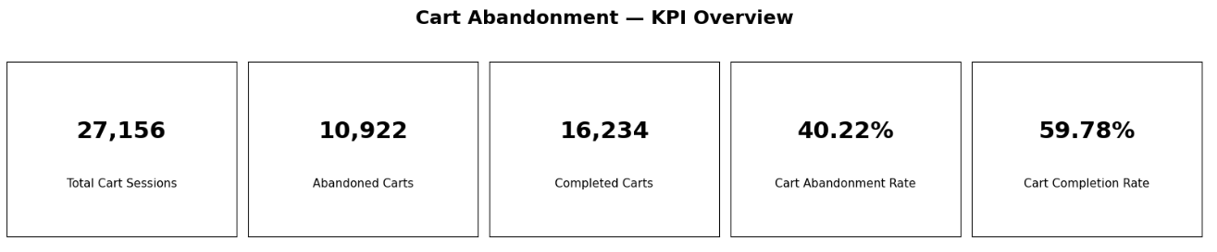

Cart Abandonment Analysis — Key Insights
9.1 Overall Performance
- 27,156 sessions added products to the cart.
- 10,922 sessions were abandoned, resulting in a 40.22% cart abandonment rate.
- 16,234 sessions progressed beyond the cart, giving a 59.78% completion rate.
- This means around 4 out of every 10 cart sessions are abandoned, making cart abandonment an important conversion opportunity.

9.2 Cart Abandonment by Device:
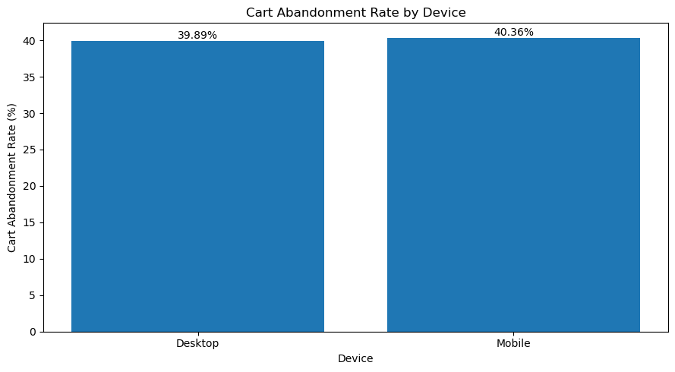
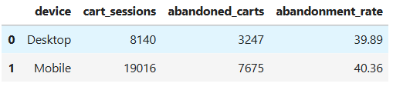

- Mobile has a slightly higher abandonment rate: 40.36% vs 39.89% for Desktop.
- The difference is only 0.47 percentage points, so device does not appear to be a major driver of cart abandonment.
- Mobile has 7,675 abandoned carts because it has much higher cart volume.

9.3 Cart Abandonment by Acquisition Channel:
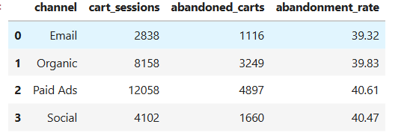

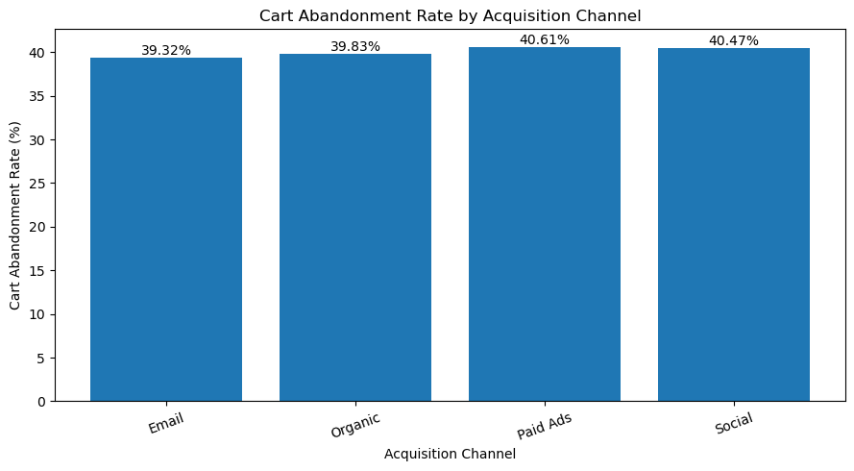
- Paid Ads has the highest abandonment rate: 40.61%.
- Social is close behind: 40.47%.
- Email has the lowest abandonment rate: 39.32%.
- However, the difference between the highest and lowest channels is only 1.29 percentage points.
- Paid Ads has the largest number of abandoned carts (4,897) because it generates the most cart sessions.
9.4 Cart Abandonment by Campaign Type:
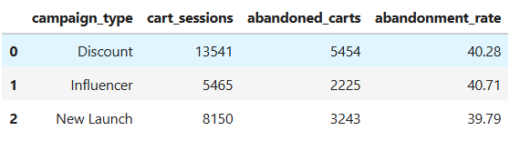
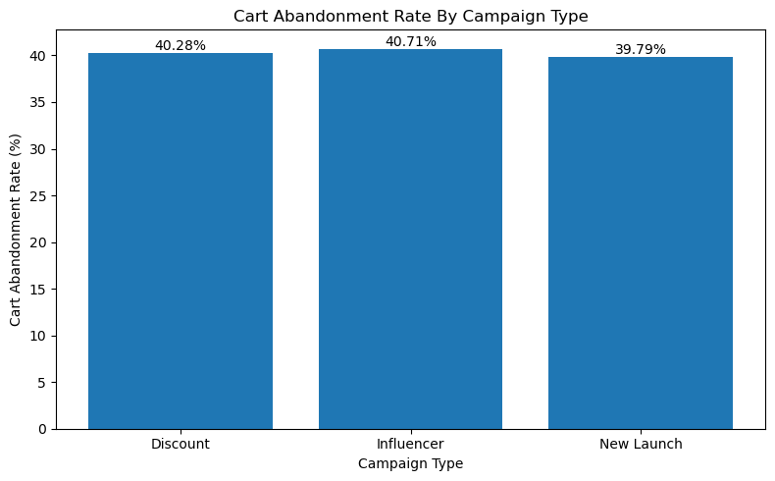
- Influencer campaigns have the highest abandonment rate: 40.71%.
- Discount campaigns: 40.28%.
- New Launch campaigns have the lowest: 39.79%.
- The difference is only 0.92 percentage points, suggesting campaign type has limited impact on cart abandonment.
9.5 Cart Abandonment by User Type:

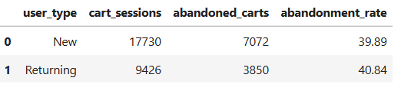

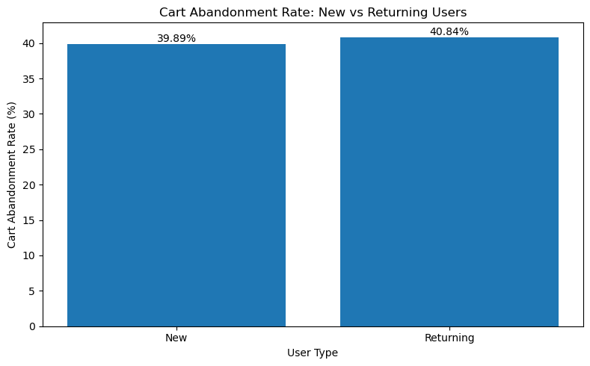

- Returning users have a slightly higher abandonment rate: 40.84%.
- New users: 39.89%.
- The difference is only 0.95 percentage points.
- This is interesting because returning users might generally be expected to have higher purchase intent, but in this dataset they show slightly higher cart abandonment.

10. Checkout Abandonment Analysis:
Checkout Abandonment Analysis — Key Insights
10.1 Overall Analysis:
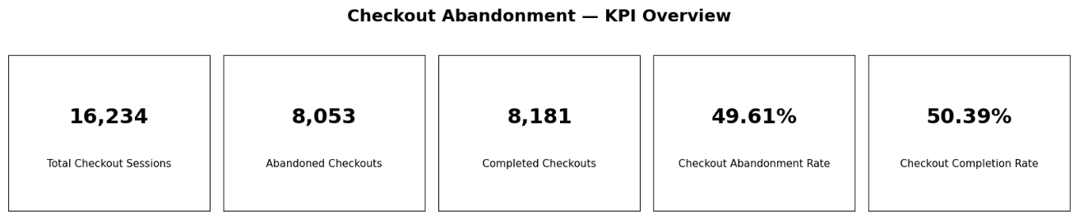

- 16,234 sessions started checkout, but only 8,181 completed a purchase.
- 8,053 checkout sessions were abandoned, resulting in a 49.61% checkout abandonment rate.
- In other words, almost 1 in 2 checkout sessions does not result in a purchase.
- Checkout abandonment is higher than your 40.22% cart abandonment rate, making Checkout → Purchase a critical conversion problem.

10.2 Checkout Abandonment by Device:

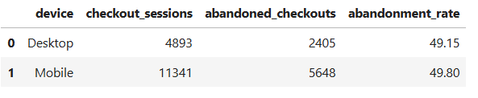

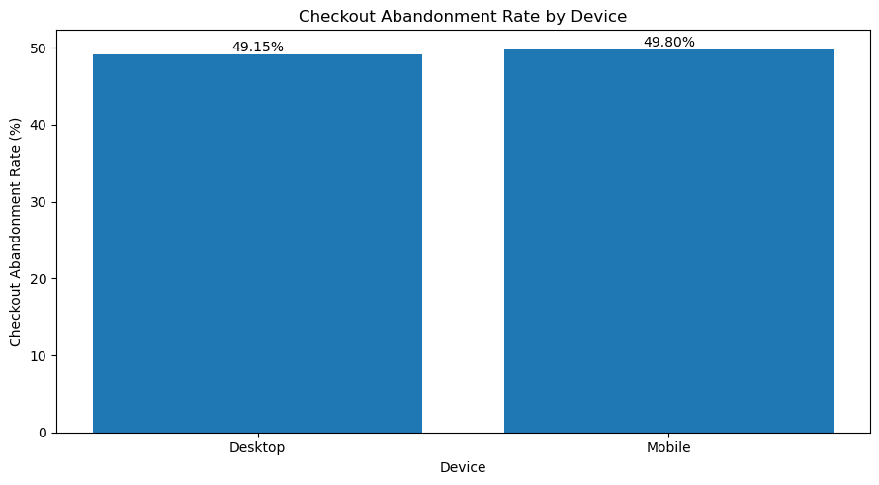
- Mobile abandonment: 49.80%
- Desktop abandonment: 49.15%
- Mobile is only 0.65 percentage points higher, so device does not appear to be a major driver of checkout abandonment.
- Mobile has the larger number of abandoned checkouts (5,648) because it generates much more checkout traffic.

10.3 Checkout Abandonment by Acquisition Channel:
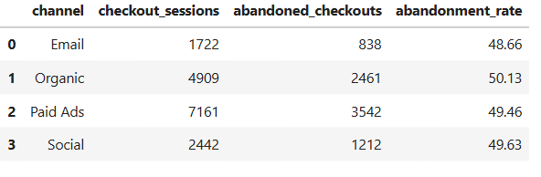

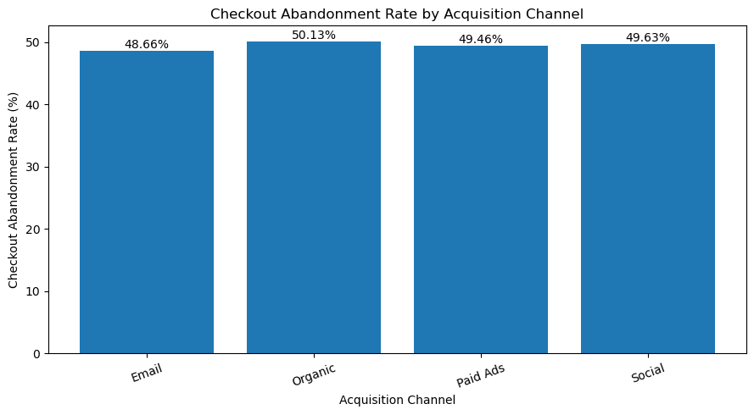

- Organic has the highest abandonment rate: 50.13%.
- Email has the lowest abandonment rate: 48.66%.
- Paid Ads: 49.46%
- Social: 49.63%
- The difference between the highest and lowest channel is only 1.47 percentage points, indicating that channel has a relatively small impact on checkout abandonment.
- Paid Ads has the largest number of abandoned checkouts (3,542) due to its high checkout volume.

10.4 Checkout Abandonment by Campaign Type:

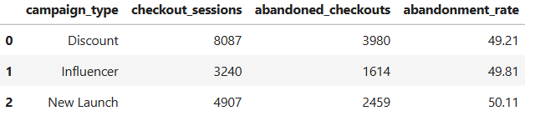

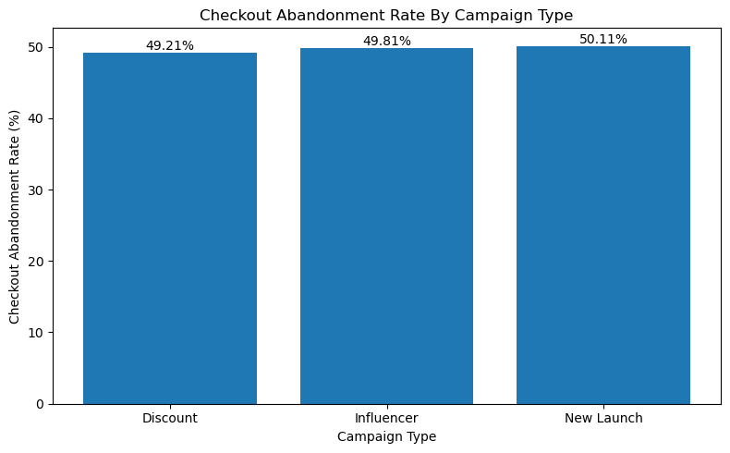

- New Launch has the highest abandonment: 50.11%.
- Influencer: 49.81%
- Discount: 49.21%
- The difference is only 0.90 percentage points, so campaign type does not appear to be a major driver.

  - Checkout Abandonment by User Type:
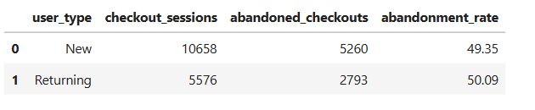

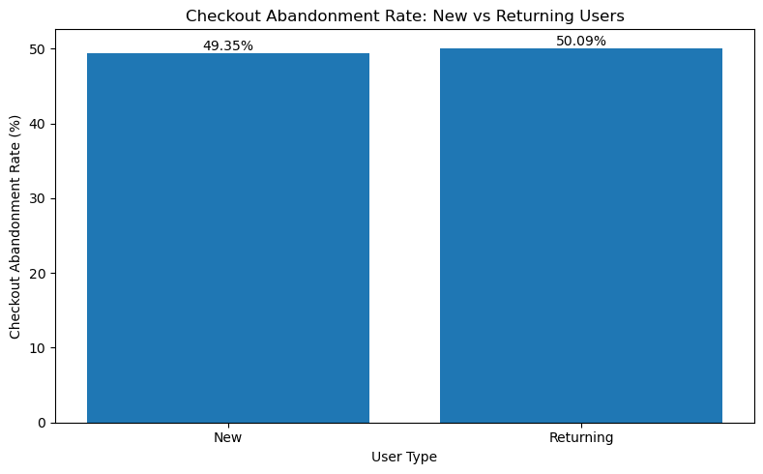

- Returning users: 50.09% abandonment
- New users: 49.35% abandonment
- Returning users abandon checkout 0.74 percentage points more than new users.
- This is consistent with our cart analysis, where returning users also had slightly higher abandonment.

Overall Business Recommendations:

Priority 1 --- Improve Product → Cart Conversion
- The biggest issue in the funnel is the Product → Cart stage, where around 65% of users drop off. Improving the product page, pricing, product information, reviews, and Add-to-Cart experience should be the first priority.

Priority 2 --- Reduce Checkout Abandonment
- Checkout abandonment is also high at 49.61%, meaning almost half of the users who start checkout don't complete their purchase. The company should look into common checkout problems such as unexpected charges, payment issues, delivery information, coupon problems, and a complicated checkout process.

Priority 3 --- Optimize High-Volume Traffic
- Paid Ads brings the most traffic and revenue, but its conversion rate is slightly lower than the other channels. Since it has a large number of users, even a small improvement in its conversion rate could result in a meaningful increase in purchases.

Priority 4 --- Learn From High-Performing Traffic
- Email performs particularly well, with the highest conversion rate and revenue per session. The company can look at what makes Email traffic more effective and apply those learnings to other acquisition channels where appropriate.
- The analysis shows that Desktop and Mobile have almost identical conversion rates, so device does not appear to be the main reason for users dropping out. However, because Mobile accounts for most of the traffic, the mobile shopping experience should still be monitored carefully.
- Campaign performance is quite similar across the different campaign types, so there is no strong evidence that one campaign type is significantly outperforming the others. Campaign decisions should therefore consider revenue, traffic, and eventually marketing costs rather than conversion rate alone.
- Cart and checkout abandonment are fairly consistent across channels, campaigns, devices, and user types. This suggests that the problem is more likely related to the overall shopping and checkout experience than to a particular customer segment.
- Returning users show slightly higher cart and checkout abandonment than new users. This is worth investigating further to understand whether factors such as product selection, pricing, previous experience, or checkout behavior are influencing them.

Priority 5 --- Use A/B Testing
- The company should start A/B testing improvements to the product and checkout pages instead of making large changes based only on assumptions. This will help determine which changes actually improve conversion.

